Year 7 Mathematics 2016
Common Test 3: 2D and 3D Geometry Time allowed: 60 mins
Total marks: 60 Name______________________
Show your working for any question worth more than one mark.

- Give two reasons why the 2D shape shown is not a polygon. [2]
________________________________________________________
________________________________________________________

- (a) What is the name of the shape on the right? [4]
______________________
(b) How many angles does it have?
______________________
(c) How many diagonals does it have?
______________________
(d) Can the shape be described as regular? Circle your answer. YES / NO

- Fill in the missing parts of the table below. The table is not in any order. [5]

Number of sides | Name of polygon
8 sides
 | Quadrilateral
7 sides
 | Nonagon
5 sides

- Give the correct name of the following triangles and give the value of the pronumeral. [6]
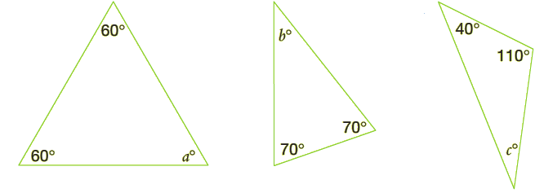

- Name: __________________ (b) Name: ________________ (c) Name: ________________
Value of a: _____ Value of b: _____ Value of c: ______

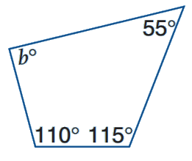
- Calculate the value of b in the following quadrilateral. [2]

b = _______________

- Calculate the value of x in each of the following. You must show your working, giving reasons where appropriate.

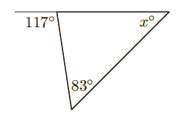

- $x=$_____________________ [2]
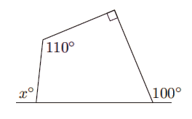

(b) $x=$_____________________ [2]
- Name the following quadrilaterals and complete the sentences below them. [4]
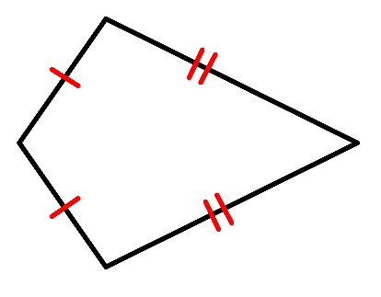

Name: _____________________ Name: ______________________
This shape has one pair of _______________ The _________________ sides in this shape are
sides equal.

- For the following questions refer to the numbered shapes shown in the box below. [7]
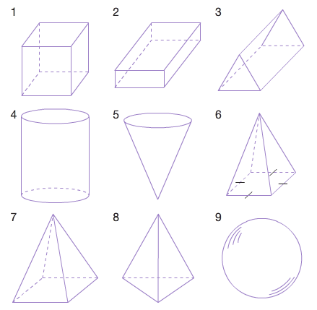
- Name solid 3:
_______________________
- Name solid 4:
_______________________
- State the number of edges for solid 4:
_______________________
- State the number of vertices for solid 1:
_______________________
- State the number of faces for solid 6:
_______________________
- Give the number of the solid which has
5 faces, 6 vertices and 9 edges.
________________________
- Give the number of the solid which has 1 face, 0 vertices and 0 edges.
________________________
- Use a ruler and a pencil to accurately draw the net of a square-based pyramid on the grid provided. [2]

- Give the name of the solid for each of the nets drawn below. [3]
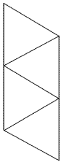
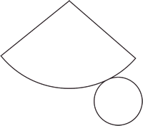
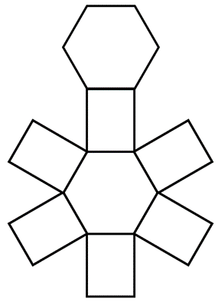

- ______________________ (b) _____________________ (c) __________________________

- Use a ruler and a pencil to accurately draw an oblique projection of a cuboid. [3]

- Use a ruler and a pencil to accurately copy the shape shown from an oblique projection to an isometric projection using the isometric paper below. [3]
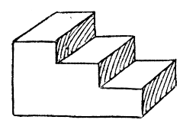

- Give the front, right and top views of the following solids. [6]
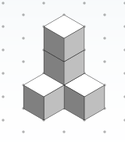
Front

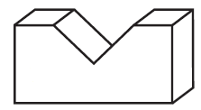

- Sketch the 3D object depicted by the top, front and side views given in the box below. [3]
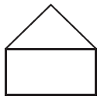

Top Front Side

- Draw the isometric projection of the object depicted by the views given. [3]
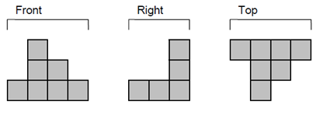

- Mr Fong asks his 5 children to weed his square garden. In his garden there is a little square pool (as shown in the diagram). He divides the garden into 5 areas of the same size for each child to work on. Show on the diagram how he divides them up evenly. [3]

Pool

The End
The extra paper below is for any questions you may need to re-do.

