Year 7 Mathematics 2015
Common Test 5: Measurement, Percentages and Probability Time allowed: 60 mins
Total marks: 60 Name______________________
Show your working for any question worth more than one mark.

- Choose the best measurements from the box below for the following:
m mL km² cm³
L mg mm km

- The length of an insect. __________________ [1]
- The capacity of an ice-cream container. __________________ [1]
- The volume of a text book. __________________ [1]

- Calculate the perimeter for the following shapes. Remember to show full working.
- (b)

7.5 km
7 cm

45 mm

__________________ [3] ___________________ [2]

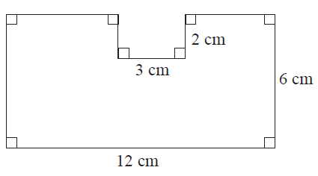

___________________ [2]

- Measure the indicated dimensions of the following shape and calculate the area and perimeter. Remember to show your working.

Height: ___________ [1]

Width: ___________ [1]

Perimeter:

Answer ______________ [2]
Area:

Answer ______________ [2]

- Calculate the area for the given shapes. Show your working.
9 cm
40 mm
5 cm
- (b)
3 m
1.5 m
2 m

Answer _______________ [2] Answer __________________ [3]

- Calculate the volume of the following objects. Working is required for (b).
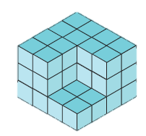
- (b)
7 cm
4 cm
2 cm

Answer ____________ cube units [1] Answer __________________ [2]

- Put the following symbols and words in the correct box to show whether they are one, two or three dimensional. [3]
m cm³ Length L Area
Volume m² Capacity Width

One dimensional | Two dimensional | Three dimensional

- Complete the table below. [6]

Percentage | Decimal | Fraction (you do not need to simplify)
42% | (a) | (b)
(c) | 1.92 | (d)
(e) | (f) | $$\frac{3}{5}$$

- What percentage of an hour is four minutes?

Answer ______________ [1]

- What percentage of a year is 3 months?

Answer ______________ [1]

- Find 34% of 500 grams

Answer ______________ [2]

- Find 61% of 300 students

Answer ______________ [2]

- If 2% of a certain number is 5. What is the number?

Answer ______________ [2]

- In an aeroplane with 280 seats there are 4% of for first class, 12% for business class and the rest are economy class.

- What percentage is economy class?
______________ [1]
- How many seats are in each of the three classes?

____________________________________ [2]

- Choose the best word from the box below to describe the probability of the following event occurring.
Impossible Unlikely
Likely Certain

- The Prime Minister will visit the school tomorrow ______________ [1]
- A quadrilateral has four sides ______________ [1]
- Someone will not clean up their mess in the cafeteria tomorrow
______________ [1]

- Twenty pieces of paper, each with a different number from one to twenty written on them, are placed in a hat. One number is drawn.

- What is the probability it is a number with a 1 in it?
________________ [1]
- What is the probability the number is less than 5? ________________ [1]
- What is the probability the number is a factor of 20?

________________ [2]
- What is the probability the number is not less than 5? ________________ [1]

- (a) Draw a tree diagram or sample space to show all the possible outcomes of spinning the following two spinners and adding the resulting numbers. [2]
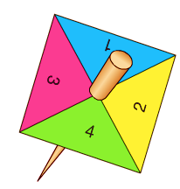
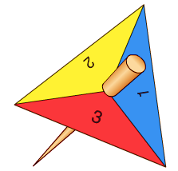

- Calculate the probability that the total of the two spinners will be 5

________________ [2]

- Find the percentage chance of survival for the following two cases. (Mac survives if he reaches water, whereas the mouse needs to reach the cheese, they never retrace their steps)

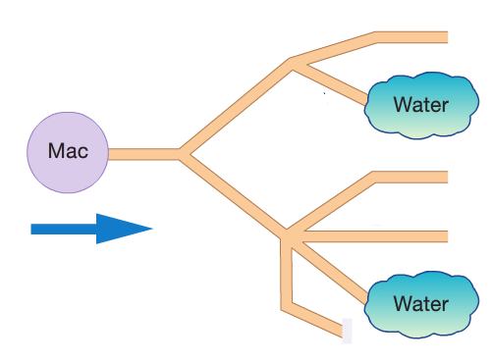
- Start with 8 life chances [2]

Answer ______________________

- Start with 30 life chances [2]
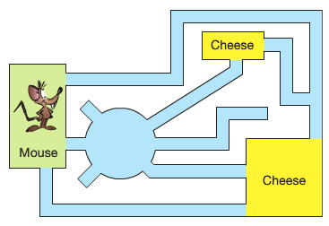

Answer ______________________

