Maths Teacher  FON / MCL / PER | Tutor Class | Name [Print clearly]

MAY EXAMINATIONS 2015

SUBJECT: Year 7 Mathematics
Time allowed: 1 hour 30 minutes |  |  | Total Marks:135

READ THESE INSTRUCTIONS FIRST

All your answers and working are to be written on the examination paper.

Calculators are permitted.

Show all your working for questions worth more than 1 mark.

Answer all questions.

The number of marks is given in [ ] at the end of each question or part question.

Section | Total | Mark
Numbers | 25
Algebra | 25
Angles/lines | 20
Decimals | 20
Directed Numbers | 20
Problem Solving | 25
TOTAL | 135

This document consists of 19 printed pages and 1 blank page

- Using the number 2789
- Give the place value of the 7 digit __________________ [1]

- What is the value of the 8 digit? __________________ [1]

- Write 3529 using expanded notation.

[1]

- Show full working for the following questions
(marks will only be awarded if correct working is shown).

- Calculate the difference between  87 and 21  [2] | - Find the sum of 65 and 47  [2]
- What is the product of 24 and 9?

[2]

- a) List all of the factors of 18 in factor pairs. [2]

- Find the highest common factor of 12 and 18.

[2]

- a) Give the first 4 multiples of 6. __________________________ [1]

- Find the lowest common multiple of 9 and 6.

__________________________ [2]

- Rewrite $5×5+2×2×2$ in index form and as a basic numeral

Index form_________________________________[2]

Basic numeral_________________________________[1]

- List the first 3 square numbers __________________________ [1]

- Using leading figure estimation on the numbers , approximate the answer to (correct working must be shown):
$$47×14=$$

__________________________ [2]

- Write 40 as a product of prime factors.

__________________________ [1]

- Complete the sentence $7×4+7×5=____(4+______)$ [2]

- Rewrite each expression in its simplest form.

  - $4×a+5×b$
______________ [2]
- $3d+6d$
______________ [1]

- Using the starting number and the rule given, write the next two numbers in each pattern.

  - 9; add 5

9 _____ _____ [2]
  - 2; multiply by 3 and add 2

2 _____ _____ [2]

- For each pattern below, write the rule used to find the next number.
- 5, 9, 13, 17

______________ [2]
- 18, 15, 12, 9

______________ [2]

- If a=5, b=9 and c=7 calculate the value of the following expressions

- 3a

______________ [1]
- 2b + 2c

______________ [1]
- 2(a + b)$÷$ c

______________ [2]

- Complete the tables below using the formulae given.
- a=2b

b | 4 | 6
a |  |  | 20

[3]
- c=3d+5

d | 3 | 5
c |  |  | 29

[3]
- Rewrite in expanded form $a^{4}$

______________ [1]
- Simplify using index notation

- $w×w×w$

______________ [1]

- $n×n+k×k×k$

______________ [2]

- Measure and classify the angles drawn below.

Angle size______________ [1]

Angle type______________ [1]

Angle size______________ [1]

Angle type______________ [1]

Angle size______________ [1]

Angle type______________ [1]

- As accurately as you can
- draw a 35$°$ angle in the space below and name it using 3 point notation. Name the angle ABC.

[2]
- draw a 230$°$ angle in the space below and give the angle type.

Angle type______________ [2]

- Complete the sentence based on the information in the diagrams shown.

A
B

Angles A and B are ________________ angles because they ___________________________
[2]

C
D

Angle C and D are ________________ angles because they ___________________________
[2]

- Draw and label the following:
- the ray AB

- the line DE

- the line segment FG

[3]

Calculate the size of the missing angles that have been labelled.
(these are not drawn to scale so can not be measured)
43°
a

a=______________ [1]
36°
b

b=______________ [1]

150°
48°
87°
c

c=______________ [1]

- Calculate the value of each of the problems below.
Show full working (no marks will be awarded without appropriate working).
- 13.52 + 1.3 + 0.256=

______________ [1]
- 18.79 -5.52=

______________ [1]
- 16.43-2.76=

______________ [1]
- 24.72 ÷ 4=

______________ [1]
- 17.43 ÷ 5= (there should be no remainder)

______________ [2]
- $16.3×3=$

______________ [1]
- $26.45×4=$

______________ [1]
- $14.54×100=$

______________ [2]
- Write 3.065 in expanded form.

__________________________________________________________________________ [1]
- Turn the fractions below into the decimal form.
Show full working ( no marks will be awarded without appropriate working)
- $\frac{5}{8}$

______________ [1]
- $\frac{11}{5}$

______________ [1]

- The times of three runners are 11.607, 11.067 and 11.67 seconds.
a) Write them in order from fastest to slowest.

__________________________________ [1]

- What is the sum of all their times? (show full working)

______________ [1]

- Write 0.675 as a fraction.

______________ [1]

- A wooden toy block is 4.3 cm high. If 6 were stacked up to make a tower how high would the tower be? (show full working)

______________ [2]

- John buys a new pencil on Monday which is 17.3 cm long. After using it for a week it is only 11.84 cm long.
What length of pencil has he used up? (show full working)

______________ [2]
- Place the following 4 numbers clearly on the number line below.
-8 , 4, -1 , -6

[4]

- Use a directed number to represent each of the following in the table below. [5]

a) | a loss of $50
 | 20 m below sea level
 | 2 floors above ground level
 | a deposit of $35 into your bank account
 | Ten degrees below zero

- Give the value of each letter written on the number line.
C
D
B
A

A=____________ B=____________ C=____________ D=____________ [4]

- a) Give the coordinates of A___________, B__________,C__________, D__________,
[4]
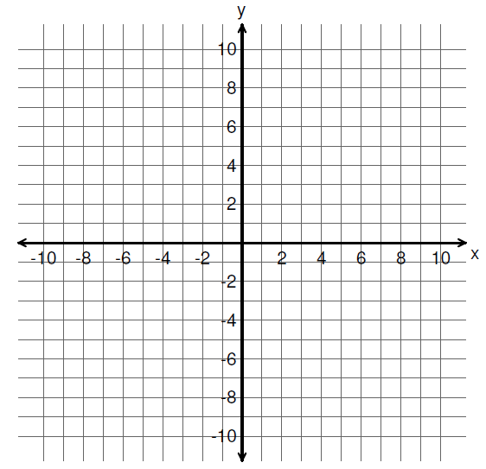
A
x
B
x
C
x
D
x

- Plot each of the points given below with an ‘x’ on the number plane above and make sure you label each one with the letter given.
E = (5, 3), F= (-8, -5), G = (-6,7)
[3]

- Two consecutive numbers (where one number is one bigger than the other) add together to equal 147 and multiply to equal 5402.
What are the two numbers?

______________ [3]

- A frog is at the bottom of a 10 metre well. The sides of the well are very slippery and when he tries to climb out he can climb up 1 metre but slips back half a metre each time. It takes him 3 minutes to climb 1 metre and 30 seconds to slip back half a metre.
How long does it take the frog to climb out of the well?

______________[2]

- A farmer has a rectangular paddock where the perimeter is 51 metres. The length of the paddock is double the width.
How long is the width and the length of the rectangular paddock?

Length = ____________[1]

Width = ____________[1]

- Fred sold square chocolates for 16 cents each and round chocolates for 11 cents. One customer bought twice as many square chocolates as round chocolates at a total cost of $4.30.
How many chocolates of each type did he buy?

Square______________

Round______________
[3]

- John and Mildred have 2 children Angela and Bernard. John is 4 years older than Mildred. Mildred is 28 years older than Angela and Angela is twice as old as Bernard. The total of all their ages is 88 years.
How old are the children?

Angela______________

Bernard______________
[3]

- Mr Mac is a very kind teacher and buys 3 boxes of chocolates with the same number of chocolates in each box, to share with his class. The class is divided into 3 groups. One group has 5 students, one has 4 students and the third group has 6 students. He gives each group a box. The groups with 4 and 5 students can share the chocolates equally in their groups with none left over but the group of 6 has two extra chocolates left over. There are less than 30 chocolates in a box.
How many chocolates are there in a box?

______________[2]

- A fish tank contains crabs and octopuses. Crabs have 10 legs and octopuses have 8 legs.
If there are 166 legs and 19 bodies in the tank, calculate how many octopuses and how many crabs there are in the tank.

Octopuses______________

Crabs______________[3]

- A pet shop sells rabbits for $9 and kittens for $7 each. The table bellows shows the amount of money the shop makes from selling rabbits and kittens over one week.
Day | Amount of money
Monday | $57
Tuesday | $25
Wednesday | $46
Thursday | $43
Friday | $53

One of these totals is wrong. Which day has the wrong figure? Explain why it is wrong.

______________[2]

- John uses 2 flashing lights when he rides his bike. The first light flashes every 18 seconds and the other one flashes every 24 seconds.
- If they are started at the same time how many seconds pass before they flash at the same time?

______________[2]

- How many times will they flash at the same time in 5 minutes?

______________[1]

- If John adds a third flashing light that flashes every 5 seconds and they are started at the same time how long will it take for all three lights to flash at the same time?

______________[2]

