|  |  |  |
| --- | --- | --- |
| **Teacher**  **FON/ MCL/ DIM** | **Class:** | **Name** [Print clearly] |

|  |  |
| --- | --- |
|  | |
| NOVEMBER EXAMINATIONS 2013 | |
| SUBJECT: Year 7 Mathematics |  |
| **Time allowed: 2 Hours** | **Total Marks: 175** |
| READ THESE INSTRUCTIONS FIRST **Answer all questions**  **The number of marks is given in brackets [ ] at the end of each question or part question.**  **This is a question and answer booklet. Write your answers in the spaces provided.**  **You may use a calculator.**  **SHOW YOUR WORKING AT ALL TIMES.**  **Do not use staples, paper clips, highlighters, glue or correction fluid.**  **Write in dark blue or black pen. You may use a pencil for diagrams, graphs or rough working.**   |  |  | | --- | --- | | **Topic** | **Marks** | | **Semester One** | **60** | | **Geometry** | **25** | | **Statistics** | **16** | | **Patterns (Algebra)** | **10** | | **Time** | **10** | | **Transformation Geometry** | **12** | | **Probability** | **10** | | **Problem Solving** | **32** | | **Total Marks:** | **175** |   **H** | |

**This document consists of 19 printed pages and 1 blank page**

**Semester One**

1. Round 135 to the nearest 10. [1]
2. In the number 63184:
3. Give the place value of the 8. [1]
4. What is the value of the 1? [1]

1. Write the number in expanded form.

[1]

1. Estimate 72 x 46 using one figure approximation (working must be shown to get marks). [2]
2. Calculate (full working must be shown to gain any marks) [7]
3. 57 – 39 =
4. 2548 ÷ 7 =
5. 52 x 37=

1. 37 – 5x 3 + 8=
2. List the factor pairs of 36:

[2]

1. Give the first 4 multiples of 3

[1]

1. Write 24 as a product of prime factors showing how you found the prime factors.   
     
     
     
     
     
     
     
     
     
     
    [2]
2. John makes model trains and uses a scale of 1:50.
3. He is going to make a model of a train carriage that is 10 metres long.   
   How long would his model be?  
     
     
     
     
     
     
    [2]
4. The height of one of John’s model train drivers is 4cm.   
   How tall is the real train driver using his original scale of 1:50?  
     
     
     
     
     
    [2]
5. Use the map to answer the questions given.

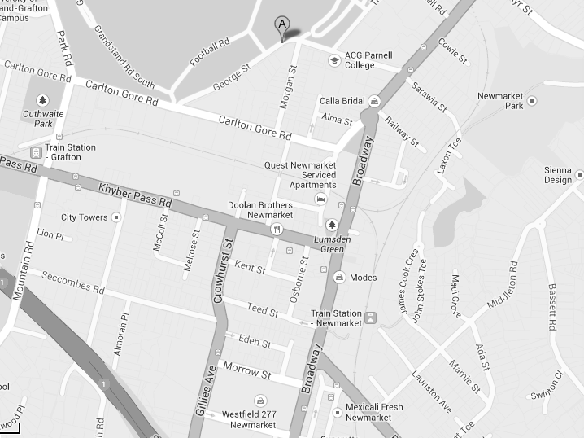

12

11

10

9

8

7

6

5

4

3

2

1

0 1 2 3 4 5 6 7 8 9 10 11 12 13 14 15

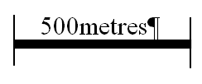

**N**

[2]

1. Give the co-ordinates of ACG Parnell College (marked with a )_____________[2]
2. What is at the co-ordinate (7.5, 6)? _________________________[1]
3. Give the length of Carlton Gore Rd.

_________________________[2]

1. Give the compass direction to travel from ACG Parnell College to City Towers.

_________________________[1]

1. Mark the co-ordinate (5,4) with an X on the map above. [1]
2. In the box below draw the locus of a soccer ball being kicked a long way and then bouncing three times before stopping.

[1]

1. Alex has 24 rings.
2. One third of them are made of gold.   
   How many gold rings does she have?

_________________________[2]

1. Six of her rings have diamonds in.   
   What fraction in simplest form have diamonds in?  
     
     
     
    _________________________[2]
2. Calculate the following giving the answer in simplest form where possible showing full working. [5]
$\frac{2}{9}+\frac{3}{9}=$

$\frac{2}{9}+\frac{3}{9}+\frac{1}{9}=$

$\frac{7}{8}-\frac{3}{8}=$

3. Complete the fractions: [2]
$\frac{3}{4}, \frac{}{12}, \frac{15}{ }$

5. Calculate the area and perimeter of the rectangle below.

4m

2m

Perimeter____________[2]

Area____________[2]

1. Calculate the volume of the cuboid shown.

3m

3m

2m

____________[2]

1. Complete the following decimal calculations.   
   Full working must be shown to gain any marks.

[7]

|  |  |
| --- | --- |
| $5.2×2.3=$ | $25.48-3.26=$ |
| $8.25÷5=$ | $5.32-3.57=$ |

1. Complete the conversion table below. [6]

|  |  |  |
| --- | --- | --- |
| Fractions | Decimals | Percentages |
|  | 0.5 |  |
| $$\frac{3}{8}$$ |  |  |
|  |  | 20% |

**Geometry**

1. Measure the angle below.
2. Write the size of the angle in the space provided.

_________________________[1]

1. On the drawing above use three point notation to label the angle ABC. [1]
2. Complete the sentence below.  
     
   The angle above is a/an ______________________ angle [1]

1. a) Using a compass and ruler draw a triangle with sides 5cm, 6cm and 8cm.

Leave your construction lines.   
(no marks will be awarded without construction lines.) [3]

1. Put the most appropriate word in the sentence below.   
     
   The triangle is a _______________ triangle. [1]
2. Complete the table below: (some have been done for you). Show proper marking to indicate equal or parallel sides or equal angles and be specific with the names.

[12]

|  |  |  |
| --- | --- | --- |
| Drawing | Name | Definition |
|  | Ray | Is a line with starting point but no end point. |
|  |  |  |
|  | Square |  |
|  |  | A polygon with 6 sides. |
|  | Trapezium |  |
|  |  | A polyhedron with 6 sides which are all squares |
|  |  |  |

Draw an oblique projection of the block figure from the question below with the side marked A as the leading edge. [3]



A

A

C

B

D

E

F

H

G



From the figure above name **one**

1. vertex _______________[1]
2. face _______________[1]
3. edge _______________[1]

**Statistics, Charts and Graphs**

1. In a swimming relay team the four swimmers can swim 100 m in 85 secs, 90 secs,   
   87 secs and 94 secs.  
   Calculate the average time for the four swimmers.

________________[2]

1. A survey is done of 20 year 5 students’ heights. The results are given in centimetres below.

136 125 136 135 125 133 133 128 125 135

124 125 133 124 125 132 133 127 136 124

1. Draw up a tally table and frequency table for the data. [3]

1. Draw a stem and leaf plot for the results. [4]

1. Using the data on heights of the children draw a Bar graph to represent the data on the graph paper below.



[5]

1. If there are 100 students in year 5 how many would you expect to be 133 cm tall?

__________________[2]

**Algebra**

1. a) Give the next 2 numbers in the sequence:

5, 12, 19, 26, ___________, ___________

[2]

b) Describe the sequence in words.   
  
  
  
  
 [2]

1. Write this formula in symbolic form.

[2]

1. Write the formula for the following sequences in symbolic form:

18, 15, 12, 9

[2]

1. Solve the equations below

$3 × a+2=17$

$a$ =_______________[1]

$20-8÷b=16$

$b$ =_______________[1]

**Time and Temperature**

1. Convert the following times between 12 and 24 hour time. [5]

|  |  |
| --- | --- |
| 5.04 pm |  |
| 12.23 pm |  |
|  | 0015 |
|  | 2145 |
| 12 pm |  |

1. If Jake leaves home at 7.43 am and arrives at work at 9.11 am how many hours and minutes has it taken for the journey.

__________hours_________mins [2]

1. Calculate how many minutes there are in 3 days.

__________________[2]

1. On a winter’s day the lowest temperature recorded was (minus) -5 degrees and the highest temperature for the day was 22 degrees. How many degrees are there between the lowest and highest temperature?

__________________[1]

**Transformations**

1. Draw in the lines of symmetry on the figure below. [2]
3. Transform the Arrow labeled A
4. Reflect A in the mirror line m1 and label the image A1 [2]
5. Rotate A about centre O 90 degrees clockwise and label the image A2 [2]
6. Reflect A in the mirror line m2 and label the image A3 [2]
7. Fully describe the single transformation that would transform
8. A to B _________________________________________[2]
9. A to C _________________________________________[2]



.O

A

B

m1

m2

C

**Probability**

2. There are 20 Pebbles in a packet. There are 5 red , 4 green, 3 yellow and 8 blue Pebbles.
3. What is the probability that when one is picked out at random it will be green?

_______________[1]

1. What is the probability that it is not blue?

_______________[1]

1. Using the same packet of Pebbles John says if he combines some of the colours he can get a probability of 0.75.

Which colours is John wanting to combine?

_______________________[1]

1. In a giant pack of Pebbles there are 140 Pebbles. How many green Pebbles would you estimate should be in the giant pack?

___________________[2]

2. Draw a tree diagram to represent 3 coins being tossed.

[3]

1. List all of the possible outcomes.

[2]

**Problem Solving**

(Working must be shown for all questions in this section)

1. Farmer Oscar wants to put a fence around his paddock and he uses 20 posts.
2. The first paddock he builds is in the shape of a square and the posts must be 2 metres apart.   
   (i) Draw a diagram of this paddock showing the position of each of the 20 posts. [1]
3. What is the area of the paddock?

_____________________[2]

1. Draw a diagram of the paddock with the smallest area that can be made with the same 20 posts also placed 2 metres apart and calculate its area.

Area= ______________________[2]

1. Fred, James and Sara all sat tests. Fred scored 84%, James got 20 out of 24 correct and Sara got $\frac{17}{20}$ of all of the questions correct. They argued about who is the smartest.  
   Show how the test results can be compared to show who the smartest is and who came second and third out of the 3 students. (working must be shown for any marks to be awarded)

first___________________

second___________________

third_________________[3]

1. Michael is paid $20 for the first 8 hours he works and is then paid $30 per hour for any hours he works after the first 8. Before he gets his pay 15% is taken out to pay tax.
2. How much will he get before paying tax if he works 11 hours?

___________________[2]

1. How much will he get after he has paid tax?

___________________[2]

1. How many hours will he need to work to get paid $263.50 after his tax has been paid?

___________________[2]

1. JoSoe had three mathematics tests this term. He got 82% in the first and 73% in the second and 85% in the third test.
2. Calculate his average for the three tests.

___________________[2]

1. What mark does he need to get in his fourth test if he is to achieve an 82% average over the four tests?

___________________[2]

1. Three children Alex, Ben and Charles are given a total of $360.

a) Alex is given three times as much as Charles and Charles gets half as much as Ben.   
Calculate how much each boy gets.

Alex _____________ Ben _____________ Charles _____________ [4]

1. The boys each use their money for different things.   
   Alex spends two thirds of his on a cell phone, Ben spends 10% of his on   
   ice-cream and Charles invests his so that he has an extra 25% after one year.

Calculate how much each boy has at the end of one year.   
  
  
  
  
  
  
  
  
  
Alex _____________ Ben _____________ Charles _____________ [3]

1. Jenny’s model train is set up on a circular track. Six telephone poles are evenly spaced around the track. The engine of the train takes 10 seconds to go from the first pole to the third pole.   
   How long would it take the engine to go all the way around the track?

_________________[2]

1. Farmer Ben keeps ducks and cows. He has 22 animals which have a total of 56 legs. All of the ducks and cows have all of their legs.   
   How many of each type of animal does he have?

Ducks=_________________

Cows=_________________

[3]

1. Leslie sold oranges. The first person brought one third of her oranges. The second person bought 4. The third person bought one quarter of the remaining oranges. At the end of the day Leslie had 15 oranges left.

How many oranges did Leslie have at the start of the day?

_________________[2]

**The End**