

**Year 7 Mathematics 2015**

**2D and 3D Space**

**Total marks: 70** **Name**______________________

***All drawings must be completed using a pencil and a ruler where appropriate.***

***You may lose marks for untidy work.***

1. Why are the following figures below not triangles? Give **one** reason for each of them.

*Answer:* __________________________________________________________________ [1]

*Answer:* __________________________________________________________________ [1]

*Answer:* __________________________________________________________________ [1]

1. Complete the table below.

|  |  |
| --- | --- |
| Number of sides | Name of polygon |
| 5 sides |  |
| 6 sides |  |
| 7 sides |  |
| 8 sides |  |
| 9 sides |  |
| 10 sides |  |

[6]

1. Name the following triangles.

|  |  |
| --- | --- |
| a.      ______________ [1] | b.      ______________ [1] |
| c.  ______________ [1] | d.  ______________ [1] |

1. Find the value of each pronumeral. Give a reason for each answer (the reason cannot be a calculation).

|  |  |  |
| --- | --- | --- |
| a.  70°  30°  *a*°  *Angle:* ______________  *Reason:* ______________________________  ______________________________  [2] | b.    50°  80°  *b°*  *Angle:* ______________  *Reason:* ________________________________  ________________________________  [2] | |
| c.  5 cm  *d* cm  50°  50°  *Side length:* ______________  *Reason:* ______________________________  ______________________________  [2] | | d. $$2a$$ $$2a$$ $$a$$*Angle:* ______________  *Reason:*________________________________  ________________________________  [2] |

1. Name the following quadrilaterals.

|  |  |
| --- | --- |
| a.  ______________ [1] | b.  ______________ [1] |
| c.  ______________ [1] | d.  ______________ [1] |
| e.    ______________ [1] | |

1. Draw below a fully labelled diagram of a rhombus. Your finished diagram will show all the properties of a **rhombus**. *Use a pencil and a ruler.*



[4]

1. Find the value of each pronumeral.

|  |  |
| --- | --- |
| a.  62°  45°  107°  a°  ______________ [1] | c.  b°  74°  88°  ______________ [2] |
| d° $$104°$$ ______________ [1] | R  E  C  T $$e°$$ $$f°$$ $$27°$$ RECT below is a rectangle $e=$ ______________ , $f=$______________ [2] |

1. For the **square** based pyramid below:

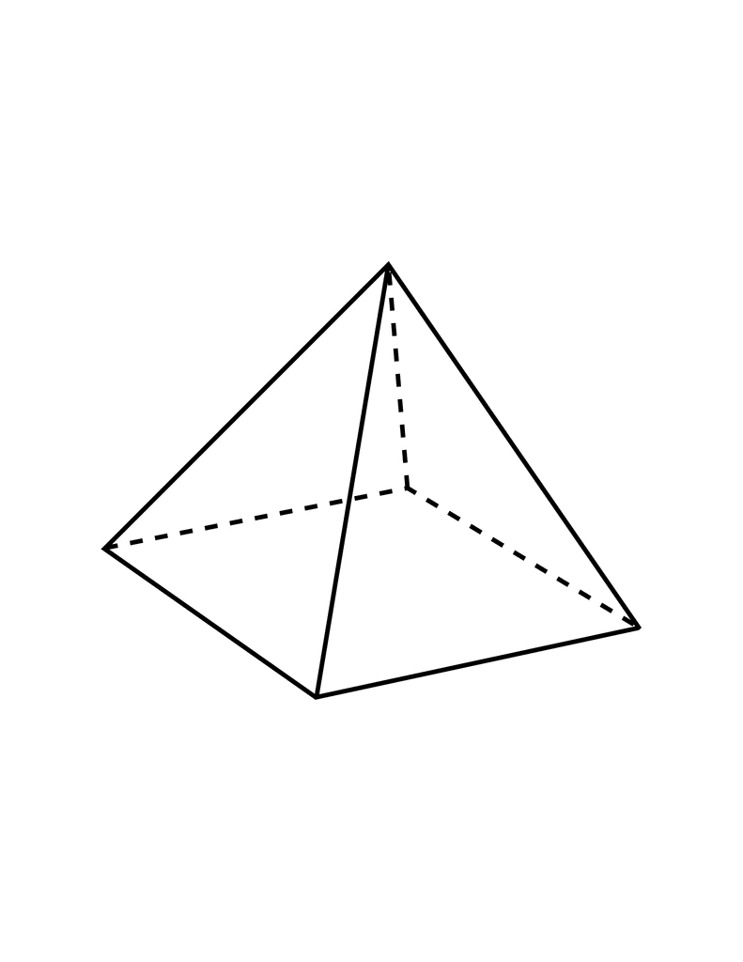

P

Q

R

S

T

* 1. List **all** of the vertices

*Answer (a):* __________________________________________________ [2]

* 1. write down the number of edges

*Answer (b):* _______ [2]

* 1. write down the names of its faces

*Answer (c):* __________________________________________________ [2]

* + 1. Name the following solids.

|  |  |  |
| --- | --- | --- |
| a. | b. | c. |

|  |  |  |
| --- | --- | --- |
| ______________________ [1] | ______________________ [1] | ______________________ [1] |

* + 1. Which of the above solids has a uniform cross-section?

______________________ [1]

1. Draw the net of the following solid on the grid provided (you do not need to include tabs in your diagram).

|  |  |
| --- | --- |
|  |  |

[3]

1. On the grid below draw a 3D drawing of a cuboid 4 units long and 2 units high.

|  |
| --- |
|  |

[3]

1. Draw the front, side and top views of the following shape on the square dot grid below.

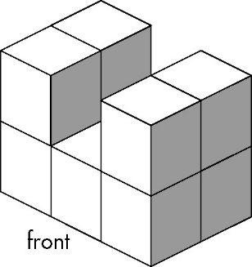

|  |  |  |
| --- | --- | --- |
| Front | Side | Top |

[3]

* 1. On the square dot grid below, draw the front view, top view (or plan) and the right-side view of the solid shown in isometric view below. *F points to the front of the solid.*

|  |
| --- |
| [3] |

* 1. On the triangle dot grid below, draw the isometric view of the solid below as it appears **looking from** directly **behind** it.

|  |
| --- |
| [3] |

1. Use the views given to draw a three-dimensional isometric drawing of the solid below.



Top

Front

Left

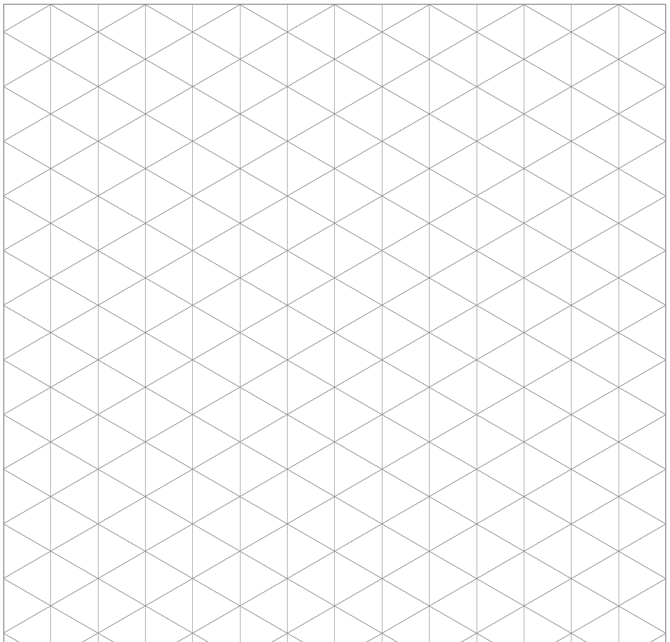

[3]

1. The following shape can be transformed into a square by making **one** straight cut and then moving the piece to a new position. Show how this can be done.

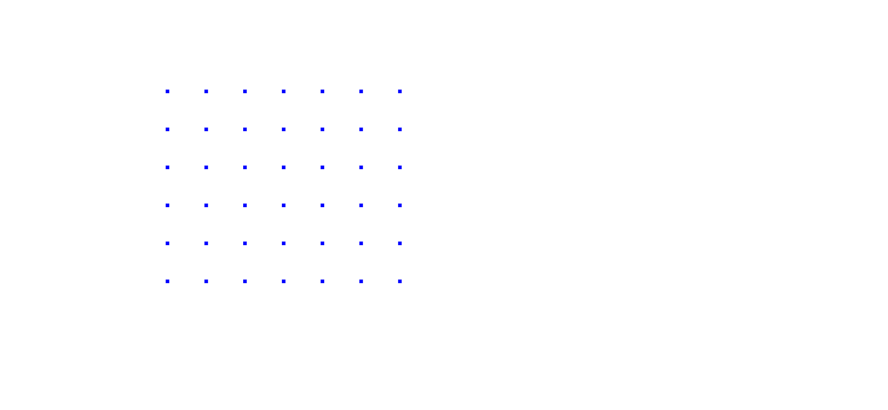

[2]

1. A rectangle has length 4 cm longer than its width. Its perimeter is 78 cm. Find the width of the rectangle.

*Note: perimeter is the distance round the outside of a shape.*

*Width:* ______________________ [2]

1. The equal sides of an isosceles triangle are 3 cm longer than the third side. If the perimeter is 18.9 cm find the length of the third side.

*Length of third side:* ______________________ [2]

**THE END**