

**Year 7 Mathematics 2016**

**Common Test 3: 2D and 3D Geometry Time allowed: 60 mins**

**Total marks: 60** **Name**______________________

Show your working for any question worth more than one mark.

1. Give **two** reasons why the 2D shape shown is not a polygon. [2]

Gap / not connected

Curved side / not straight

1. (a) What is the name of the shape on the right? [4]

hexagon

(b) How many angles does it have?

6

(c) How many diagonals does it have?

9

(d) Can the shape be described as regular? *Circle your answer.*  YES / NO

1. Fill in the missing parts of the table below. *The table is not in any order*. [5]

|  |  |
| --- | --- |
| Number of sides | Name of polygon |
| 8 sides | Octagon |
| 4 sibes | Quadrilateral |
| 7 sides | Heptagon |
| 9 sibes | Nonagon |
| 5 sides | Pentagon |

1. Give the correct **name** of the following triangles **and** give the value of the **pronumeral**. [6]

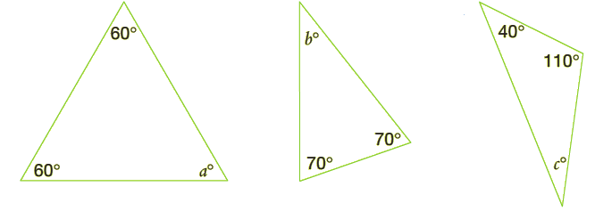

1. Name: Equilateral (b) Name: Isosceles (c) Name: Scalene

Value of *a*: 60˚ Value of *b*: 40˚ Value of *c*: 30˚

1. 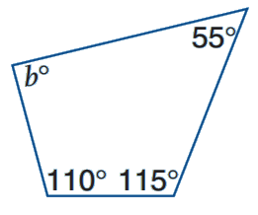Calculate the value of *b* in the following quadrilateral. [2]

✓ Must show working:

360 – 55 – 110 – 115 OR 280˚ seen

*b* = 80˚

1. Calculate the value of *x* in each of the following. You must show your working, giving reasons where appropriate.



1. 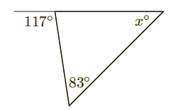



1. $x=$ 34˚ [2]
2. 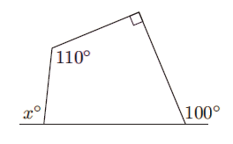



(b) $x=$ 100˚ [2]



1. Name the following quadrilaterals and complete the sentences below them. [4]

[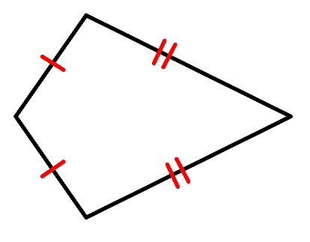](https://www.google.co.nz/url?sa=i&rct=j&q=&esrc=s&source=images&cd=&cad=rja&uact=8&ved=0ahUKEwi0wqalx5rNAhXBhaYKHXVnANUQjRwIBw&url=https://commons.wikimedia.org/wiki/File:Kite_definition.svg&bvm=bv.124088155,d.dGY&psig=AFQjCNHJe3J-dfygKMGal6YK5rY9vVQdCw&ust=1465548373773788)

Name: Trapezium Name: Kite

This shape has one pair of parallel The adjacent sides in this shape are

sides equal.

1. For the following questions refer to the numbered shapes shown in the box below. [7]

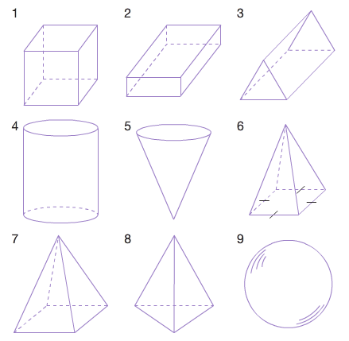

1. Name solid 3:

Triangular Prism

1. Name solid 4:

Cylinder / Circular Prism

1. State the number of edges for solid 4:

2

1. State the number of vertices for solid 1:

8

1. State the number of faces for solid 6:

5

1. Give the number of the solid which has

5 faces, 6 vertices and 9 edges.

Solid 3 or Triangular prism

1. Give the number of the solid which has 1 face, 0 vertices and 0 edges.

Solid 9 or Sphere

1. Use a ruler and a pencil to accurately draw the net of a square-based pyramid on the grid provided. [2]

|  |  |  |  |  |  |  |  |  |  |  |  |  |  |  |  |  |  |  |  |  |  |  |
| --- | --- | --- | --- | --- | --- | --- | --- | --- | --- | --- | --- | --- | --- | --- | --- | --- | --- | --- | --- | --- | --- | --- |
|  |  |  |  |  |  |  |  |  |  |  |  |  |  |  |  |  |  |  |  |  |  |  |
|  |  |  |  |  |  |  |  |  |  |  |  |  |  |  |  |  |  |  |  |  |  |  |
|  |  |  |  |  |  |  |  |  |  |  |  |  |  |  |  |  |  |  |  |  |  |  |
|  |  |  |  |  |  |  |  |  |  |  |  |  |  |  |  |  |  |  |  |  |  |  |
|  |  |  |  |  |  |  |  |  |  |  |  |  |  |  |  |  |  |  |  |  |  |  |
|  |  |  |  |  |  |  |  |  |  |  |  |  |  |  |  |  |  |  |  |  |  |  |
|  |  |  |  |  |  |  |  |  |  |  |  |  |  |  |  |  |  |  |  |  |  |  |
|  |  |  |  |  |  |  |  |  |  |  |  |  |  |  |  |  |  |  |  |  |  |  |

1. Give the name of the solid for each of the nets drawn below. [3]

[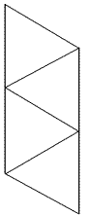](http://www.google.co.nz/url?sa=i&rct=j&q=&esrc=s&source=images&cd=&cad=rja&uact=8&ved=0ahUKEwiW4fLFy5rNAhXj2qYKHSSZAh0QjRwIBw&url=http://www.regentsprep.org/regents/math/geometry/gg2/netpage.htm&psig=AFQjCNHLgQ_AZ89H-4MWuOZA2SW-yDLT-g&ust=1465549496366569)[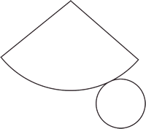](http://www.google.co.nz/url?sa=i&rct=j&q=&esrc=s&source=images&cd=&cad=rja&uact=8&ved=0ahUKEwjZrdrby5rNAhVD6aYKHa4SCx8QjRwIBw&url=http://www.emathematics.net/shapes3d.php?def%3Dnet&psig=AFQjCNGevLkaWxhemF96--6mTnvQVKvuAQ&ust=1465549560729539)[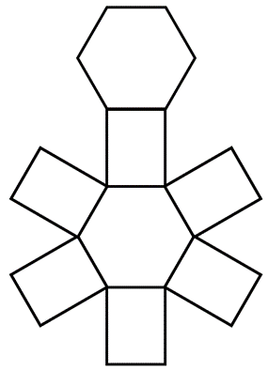](http://www.google.co.nz/url?sa=i&rct=j&q=&esrc=s&source=images&cd=&cad=rja&uact=8&ved=0ahUKEwj465X_y5rNAhXjMqYKHWOjC7AQjRwIBw&url=http://www.math-salamanders.com/geometry-nets.html&psig=AFQjCNElygDe-aehEBwHJKJ-_dYz192MrA&ust=1465549630049136)

1. Triangular Pyramid (b) Cone, Circular Pyramid (c) Hexagonal Prism
2. Use a ruler and a pencil to accurately draw an oblique projection of a cuboid. [3]



1. Use a ruler and a pencil to accurately copy the shape shown from an oblique projection to an isometric projection using the isometric paper below. [3]



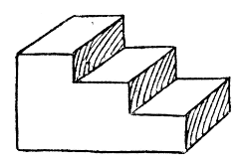



1. Give the front, right and top views of the following solids. [6]
2. 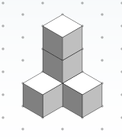



Front

|  |  |  |  |  |  |  |  |  |  |  |  |  |  |  |  |  |  |  |  |  |  |  |
| --- | --- | --- | --- | --- | --- | --- | --- | --- | --- | --- | --- | --- | --- | --- | --- | --- | --- | --- | --- | --- | --- | --- |
|  |  |  |  |  |  |  |  |  |  |  |  |  |  |  |  |  |  |  |  |  |  |  |
|  |  |  |  |  |  |  |  |  |  |  |  |  |  |  |  |  |  |  |  |  |  |  |
|  |  |  |  |  |  |  |  |  |  |  |  |  |  |  |  |  |  |  |  |  |  |  |
|  |  |  |  |  |  |  |  |  |  |  |  |  |  |  |  |  |  |  |  |  |  |  |
|  |  |  |  |  |  |  |  |  |  |  |  |  |  |  |  |  |  |  |  |  |  |  |
|  |  |  |  |  |  |  |  |  |  |  |  |  |  |  |  |  |  |  |  |  |  |  |
|  |  |  |  |  |  |  |  |  |  |  |  |  |  |  |  |  |  |  |  |  |  |  |
|  |  |  |  |  |  |  |  |  |  |  |  |  |  |  |  |  |  |  |  |  |  |  |
|  |  |  |  |  |  |  |  |  |  |  |  |  |  |  |  |  |  |  |  |  |  |  |

|  |  |  |  |  |  |  |  |  |  |  |  |  |  |  |  |  |  |  |  |  |  |  |
| --- | --- | --- | --- | --- | --- | --- | --- | --- | --- | --- | --- | --- | --- | --- | --- | --- | --- | --- | --- | --- | --- | --- |
|  |  |  |  |  |  |  |  |  |  |  |  |  |  |  |  |  |  |  |  |  |  |  |
|  |  |  |  |  |  |  |  |  |  |  |  |  |  |  |  |  |  |  |  |  |  |  |
|  |  |  |  |  |  |  |  |  |  |  |  |  |  |  |  |  |  |  |  |  |  |  |
|  |  |  |  |  |  |  |  |  |  |  |  |  |  |  |  |  |  |  |  |  |  |  |
|  |  |  |  |  |  |  |  |  |  |  |  |  |  |  |  |  |  |  |  |  |  |  |
|  |  |  |  |  |  |  |  |  |  |  |  |  |  |  |  |  |  |  |  |  |  |  |
|  |  |  |  |  |  |  |  |  |  |  |  |  |  |  |  |  |  |  |  |  |  |  |
|  |  |  |  |  |  |  |  |  |  |  |  |  |  |  |  |  |  |  |  |  |  |  |
|  |  |  |  |  |  |  |  |  |  |  |  |  |  |  |  |  |  |  |  |  |  |  |



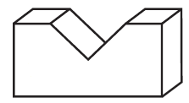

1. **Sketch** the 3D object depicted by the top, front and side views given in the box below. [3]

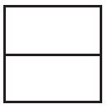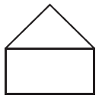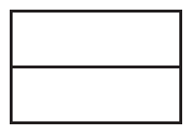

Top Front Side

1. Draw the isometric projection of the object depicted by the views given. [3]

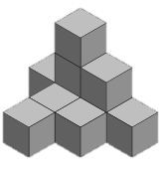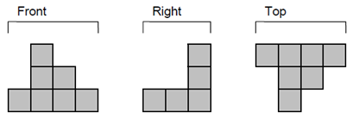





1. Mr Fong asks his 5 children to weed his square garden. In his garden there is a little square pool (as shown in the diagram). He divides the garden into 5 areas of the same size for each child to work on. Show on the diagram how he divides them up evenly. [3]



|  |  |  |  |
| --- | --- | --- | --- |
|  |  |  |  |
|  |  |  |  |
|  |  | Pool |  |
|  |  |  |  |

The End

*The extra paper below is for any questions you may need to re-do.*

