

**Year 7 Mathematics 2012**

**Measurement and Location Test**

**Total marks:** 58 **Name**______________________

**Show your working for any question worth more than one mark.**

1. **Measure** the shape below and calculate its **perimeter.** Remember to put the correct units in your answer.

*Answer* (1) _______________ [4]

2. **Calculate** the **perimeter** of the shape below.

2 m

7 m

Not drawn to scale

*Answer* (2) _______________ [3]

3. Give the **best** unit for measuring the following

a) The capacity of a water bottle ____________________ [1]

b) The area of thumb print ____________________ [1]

c) The mass of a chair ____________________ [1]

d) The height of a desk ____________________ [1]

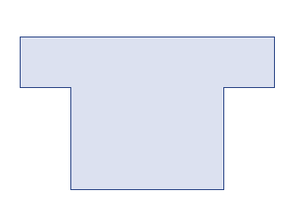4. Calculate the **perimeter** of the following shape.

14 m

8 m

6 m

2 m

*Answer* (4) _________________ [3]

5. Determine the **area** of the following shapes.

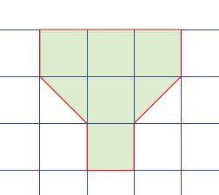a) b)

4 cm

8 cm

*Answer* (5a) $cm^{2}$___________ [1] *Answer* (5b) _______________ [3]

6. Determine the **area** of **shaded** shape below

9 mm

22 mm

*Answer* (6) _________________ [3]

7. Determine the volume of the prism shown. Each block is 1 $cm^{3}$

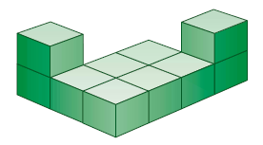

*Answer* (7) _________________ [1]

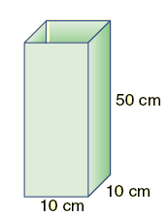8. (a) Calculate the **volume** of the prism shown. (b)Calculate the **capacity** of the container shown.

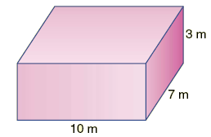

*Answer* (8a) _________________ [3] *Answer* (8b) _________________ [3]

9. Fill in the gaps below:

1. There are ____________ millimetres in a metre. [1]
2. If a cylinder can hold 300 ml of water, its volume is __________ cm3. [1]
3. A square with each side measuring ____________ has an area of 81 cm2 and a perimeter of ___________. [2]
4. An elephant at the zoo weighs 6.3 ____________. [1]

11.The diagram below shows a treasure map.

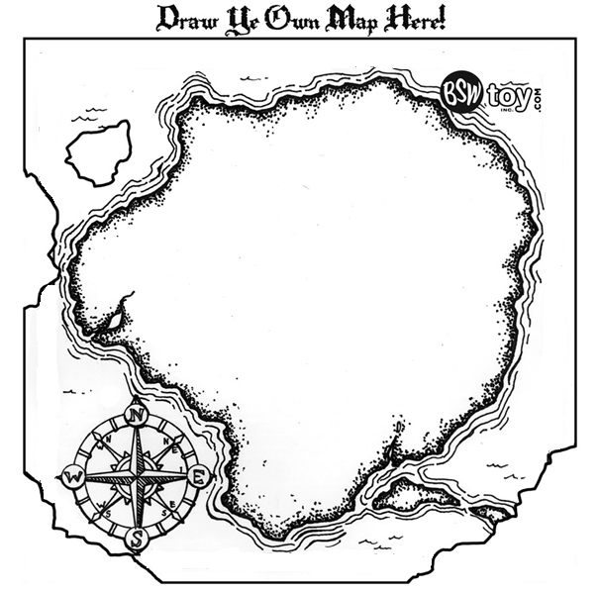

|  |  |  |  |  |  |  |  |  |  |  |
| --- | --- | --- | --- | --- | --- | --- | --- | --- | --- | --- |
| **11** |  |  |  |  |  |  | http://2.bp.blogspot.com/-mgkC5oagUSg/TyVzAs-spOI/AAAAAAAAAnk/OGO7kWNJEBU/s400/peterpan_118182159_std.gif |  |  |  |
| **10** |  |  |  |  |  |  |  |  |  |  |
| **9** |  |  |  | http://www.arnan.com/arnan/cartoon_forest.jpg |  | Peter Pan |  |  |  |  |
| **8** |  |  |  | Haunted Forest |  |  |  |  |  |  |
| **7** |  |  |  |  |  |  | Blackbeard’s  Hut |  |  |  |
| **6** |  |  |  |  |  |  |  |  |  |  |
| **5** |  |  |  | http://www.supercoloring.com/wp-content/main/2010_07/pirate-flag-coloring-page.jpg |  |  |  |  |  |  |
| **4** |  |  |  |  |  |  |  |  |  |  |
| **3** |  |  |  |  |  |  |  |  |  |  |
| **2** |  |  |  |  |  |  |  |  |  |  |
| **1** |  |  |  |  |  |  |  |  |  |  |
|  | **A** | **B** | **C** | **D** | **E** | **F** | **G** | **H** | **I** | **J** |

a) The lion _________________ [2]

Scale: 1 grid represents 100 m

1. At grid reference H5 draw a cave entrance [1]
2. 200 m North of the pirate flag is a pond, draw the pond. [1]
3. Give the grid reference of the hut __________________ [1]
4. X marks the treasure, giving the distance and only using horizontal and vertical steps explain how Peter can get to the treasure

________________________________________________________________________________

___________________________________________________________________________ [2]

1. How far did Peter have to walk? __________________ [1]
2. What is situated South East of Peter? __________________ [1]

12. Below is a picture of Mr Edmeades’ house and section. The scale is 2 cm represents 4 m.

Garage

Front

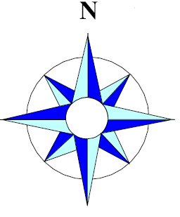

House

(a) Rewrite the scale in ratio format 1: ________ [1]

(b) Give the dimensions of the house in real life

Width: __________ Length: _____________ [2]

(c) Mr Edmeades wants to build a garage. The dimensions need to be 4 m by 5 m. Draw to scale a garage in the shaded area of his section.

[2]

(d) Mr Edmeades wants to plant an oak tree in the south-east corner of his yard. Oak trees grow to be very large and he knows the tree will need to be planted at least 3 metres away from the fence. Draw a suitable place for the oak tree. [2]

(e) Rudolf, Mr Edmeades pet dog, likes to patrol the front fence. He walks in a straight line 1 metre away from the fence, draw the loci of where the dog would walk. [1]

13.



Give the coordinates of:

a) Point A _____________________ [2]

b) Point B _____________________ [2]

Draw and label the following

c) Point C at (0,5) [2]

**A**

d) Point E at (5,2) [2]

**B**

14. Draw the locus of a swimmers hand as he swims freestyle across the school pool.

[1]

15. A goat is tied to a rail so the chain can slide up and down the rail, which of the following pictures best shows the locus of the goat? (Circle the letter of the correct picture).

A.

Rail

 B.

C.

[1]