|  |  |  |  |  |
| --- | --- | --- | --- | --- |
| **­Name** [Print clearly] | **Class:** | **Mathematics Teacher** | | |
|  | | | | |
| November 2010 EXAMINATIONS | | | | |
| |  | | --- | | SUBJECT: Mathematics | | **Time allowed:** | |  | YEAR LEVEL :7 | |  |
| **2 hours** |  |  | **Total Marks: 140** | |
| READ THESE INSTRUCTIONS FIRST  * All your answers and working are to be written on the examination paper. * **Calculators are permitted.** * **Show all your working.** * Answer **all** questions. * The number of marks is given in [ ] at the end of each question or part question.  |  |  |  | | --- | --- | --- | | Section | Total | Mark | | **Semester 1** | **40** |  | | **2D Geometry** | **10** |  | | **Probability** | **10** |  | | **Statistics** | **15** |  | | **Measurement** | **15** |  | | **Time** | **15** |  | | **3D Geometry** | **10** |  | | **Transformations** | **10** |  | | **Problem Solving** | **15** |  | | **TOTAL** | **140** |  | | | | | |

**This document consists of 22 printed pages**

**Semester One**

1. Starting at the point (5,5) draw a line 3 units long to the East of the point , then another line 5 units long heading North and a line 3 units to the West and then 5 units heading South . [1]



N

1. Give the coordinates of each of the vertices of the shape you have drawn.

__________, __________, __________,__________ [3]

1. If each unit on the grid represents 3 metres, what are the dimensions of the shape you have drawn?

_____________________ [2]

1. Below is a drawing of a part of the track of a roller coaster ride.   
   a) Draw the locus of a carriage 6m above the track. [1]  
     
     
     
     
     
     
     
     
   Scale : 1mm represents 3m  
     
   b) Using the scale given in the drawing calculate how long the ride is?

A

_______________________ [2]

1. Accurately draw an extra section of the roller coaster ride at the end marked A that represents 90 metres using the scale given in the diagram.   
   Show how you calculated the length of the line you need to draw in.

[2]

1. Joanne was born in January 1985 and is 19 years old. How old will she be in December 2013?  
     
    _______________________ [1]
2. Using the number 38624 give the:
3. place value of the 6 _________________________ [1]
4. value of the 8 _________________________ [1]
5. round the number to the nearest hundred _________________________ [1]
6. write the number in expanded form.

_________________________________________________________________ [1]

1. a) Find the sum of 3 and 5.

_________________________ [1]

b) Give the product of 6 and 8.

_________________________ [1]

1. Calculate the following

$9+15 ×3=$

_________________________ [1]

$2 ×\left(11-2\right)÷3=$

_________________________ [1]

1. a) From the list of numbers given below place each number in the correct box. [3]

**6, 23, 4, 7, 15, 60,**

|  |  |  |
| --- | --- | --- |
| **Prime Numbers** | **Factors of 24** | **Multiples of 5** |
|  |  |  |

1. Give a number that is **not in the list** that would fit into both the Prime Number and Factors of 24 boxes.

_________________________ [1]

1. Give 2 composite numbers from the list above in a).

_________________________ [1]

1. In a class of 24 students $\frac{3}{8}$ wear glasses.
2. How many students wear glasses in the class?

_________________________ [1]

1. If there are 18 boys in the class, give the fraction of girls in the class.   
   (Give your answer in simplest terms.)

_________________________ [2]

1. A quarter of the class picked Justin Bieber as their favourite singer and $\frac{5}{8}$ of the class picked Taylor Swift, rest said they didn’t have a favourite singer.   
   How many had no favourite?

_________________________ [2]

1. What is the lowest common multiple of 2, 3 and 8 (show working).

_________________________ [2]

1. The height of a basketball hoop from the floor is 3.05 metres. The top of Albert’s head is 0.562 metres below the hoop.
2. How tall is Albert? (full working must be shown)

_________________________ [1]

1. If Albert is twice as tall as his younger sister Bethany, how tall is Bethany?   
   (full working must be shown)

_________________________ [1]

1. In the number 3.05, what is the place value and value of the 5?

Place value___________________ [1]

Value___________________ [1]

1. a) Find 22% of 550.

_________________________ [1]

1. If Janet scored 28 out of 40 in a test, what would her percentage be?

_________________________ [1]

1. Complete the table below: [2]

|  |  |  |
| --- | --- | --- |
| **Fraction**  (simplest form) | **Decimal** | **Percentage** |
| $$\frac{5}{8}$$ |  |  |
|  | 0.32 |  |

**2D Geometry**

1. 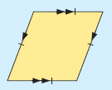

A

D

C

B

x

1. Name the shape shown. ________________________ [1]
2. Use 3 point notation to name the angle marked x in the figure

________________________ [1]

1. Name one pair of parallel lines. ________________________ [1]
2. Measure an obtuse angle in the figure ________________________ [1]
3. Complete the following sentences:
4. A reflex angle is between ___________and __________ degrees. [1]
5. A polygon with eight sides of equal length and eight equal angles   
   is called a ________________ __________________ [1]
6. _______________________ triangles have two equal sides. [1]
7. If the radius of a circle is 3cm the diameter is _________cm [1]
8. Accurately draw a reflex angle and show the number of degrees.

[2]

**Probability**

1. Jake has a bag of lollies containing 5 yellow, 6 brown and 4 red lollies.
2. What is the probability of picking a red lolly?

________________ [1]

1. Jake ate a yellow lolly and a brown lolly.   
   What is the probability of picking a brown one next?

________________ [1]

1. John has 3 different coloured shirts, white, blue and green. His trousers are either black or blue and his shoes black or brown.
2. Draw a clearly labelled tree diagram to show the possible combinations of colours John could wear if he had to choose one shirt, one pair of trousers and a pair of shoes. [3]

b) Carefully list all the different combinations that John could wear. [2]

1. The spinner shown is made from a regular hexagon.

1

2

3

1. What is the probability of getting a 3 on the spinner?

_____________[1]

1. Give the probability of getting a 2.

_____________[1]

1. A survey of cars showed that 85% were made in Japan. In a city where there are   
   200,000 cars, estimate how many would be made in Japan.

_____________________ [1]

**Statistics**

1. Below is a set of test results from a class of 20 students.

**18 24 11 16 17 15 30 21 10 12 17 14 23 19 18 28 29 24 20 14**

1. Draw a stem and leaf graph of the test results [3]
2. Calculate the mean test mark for this class. (full working must be shown) [2]

_____________________ [2]

1. The teacher has grouped the scores into the tally table below. The three groups have been done for you. Complete the Tally and Frequency table. [2]

**Test Scores by Group**

|  |  |  |
| --- | --- | --- |
| Test Scores | Tally | Frequency |
| 0-5 |  |  |
| 6-10 |  |  |
| 11-15 | **I I I I I** | **5** |
| 16-20 | **I I I I I I** | **7** |
| 21-25 |  |  |
| 26-30 | **I I I** | **3** |

1. Draw a strip graph of the Frequency data from the table in part (c).   
   Make sure to show the scale you are using for your strip graph. [2]
2. Using the information from the ‘Test Scores by Group’ table above estimate how many students out of 300 would get a score between 16-20

_____________________ [2]

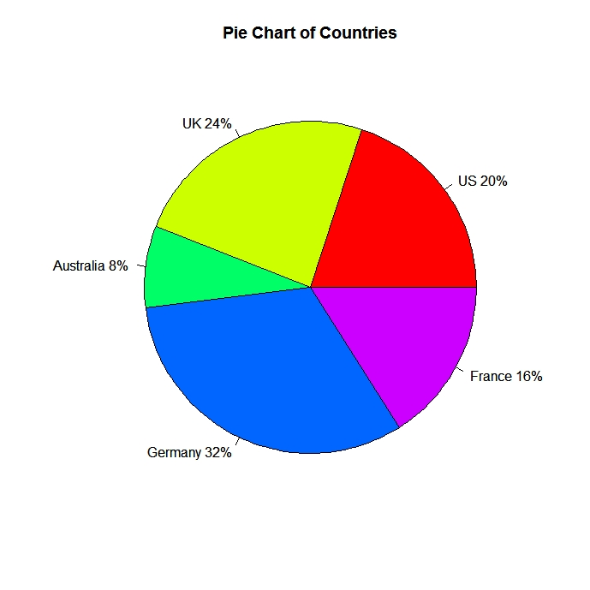

1. Here is a pie chart showing the different countries the 300 passengers on an aeroplane came from.

Using this information from the pie chart calculate how many passengers came from France?   
(show full working)

______________________[2]

**Measurement**

1. a) Measure the rectangle below in millimetres and write in the length and width in the spaces provided. [2]

Length___________________

Width __________

1. Calculate the area of the rectangle.

__________________________ [2]

1. Calculate the perimeter of the rectangle.

__________________________ [2]

1. In the stairs shown below, all of the lengths marked are 9cm.

|  |  |  |  |
| --- | --- | --- | --- |
|  |  |  |  |
|  |  |  |  |
|  |  |  |  |
|  |  |  | 9cm |

1. Calculate the perimeter of the shape shown.

__________________________ [2]

1. Calculate the area of the shape.

__________________________ [2]



5cm

3cm

4cm

1. Calculate the volume of the box.

_________________________ [2]

1. Give the capacity of the box.

_________________________ [1]

1. Complete the conversions in the table below. [2]

|  |  |
| --- | --- |
| 2.5 km | m |
| 6500g | kg |
| 10.35m | cm |
| 150 cm3 | mL |

**Time**

1. Complete the following times. [2]

|  |  |
| --- | --- |
| 12 hour time | 24 hour time |
| 5:10 am |  |
|  | 1643 |
| 12:02 am |  |
|  | 0005 |

1. John started a marathon race at 0933 and crossed the finish line at 1316.
2. How long did he take to complete the race? Give your answer in hours and minutes.

__________ hrs __________mins [2]

1. After the race it took John 7500 seconds to get home.   
   What time did he arrive home? Give your answer in 12 hour time.

________________________ [2]

1. a) How many days are there from November 19th 2010 to February 19th 2011 including these two days.

________________________ [2]

1. How many years are there in 208 weeks? (show full working).

________________________ [2]

1. Below is a timetable for the airport bus in Wellington.

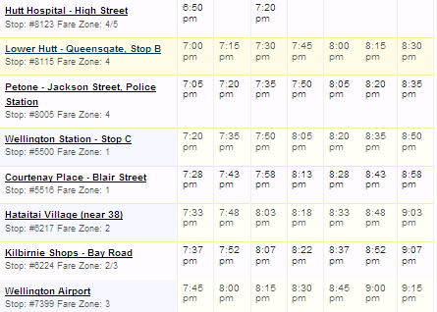

a) How long does the bus take to go from Hutt Hospital to the Kilbirnie Shops?

________________________ [1]

1. If you were catching a 9pm flight and needed to arrive at the airport at least 35 minutes before the flight, what is the latest bus you could catch from Petone?

________________________ [2]

1. The blades on a large water wheel turn as it is driven by the water flowing through a river. The wheel takes 2 minutes and 10 seconds to turn once. How many complete turns will it make in 24 hours?

________________________ [2]

**3D Geometry**

1. a) Name the shape on the right.

_______________________[1]

1. How many faces does the shape have?

_______________________[1]

1. Name the Polyhedra that each of the nets below makes.   
   Write the name in the space below each one. [2]

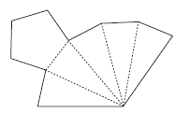

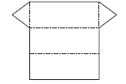

a)_______________________ b)_________________________

1. Draw an oblique projection and an isometric projection of the shape shown in the plan below. Label which is the Isometric and which is the oblique in the space given above each picture. [4]

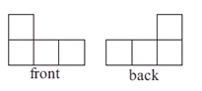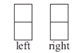





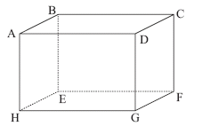

1. Using the figure shown on the right,
2. Name one face ____________________[1]
3. Name one edge.____________________[1]

**Transformations**

1. a) Enlarge the figure by scale factor of 2.

[2]



1. Reflect the trapezium below in the mirror line M [2]

M1



A

1. On the grid above translate the original trapezium 5 right and 2 up. Label the translated figure T. [2]
2. a) Rotate the parallelogram on the grid 90° clockwise using the centre marked O and label the new figure 90. [1]
3. Rotate the original parallelogram 270°clockwise using the centre marked O.   
   Label the new parallelogram 270. [1]



O

1. a) Draw in the lines of symmetry for figure given below. [1]
2. How many times would the figure map onto itself through a 360o rotation?

_________________________ [1]

**Problem Solving**

1. On the planet ZXY they have two different species of toad, one has 5 horns and the other species has 2 horns. Both species of toad have 3 legs. Jonny keeps some of the toads as pets. His mother let them escape while cleaning his room. She was not sure how many toads he had but knew that once she had counted 64 horns and 51 legs altogether on the toads.

How many of each species of toad did Jonny have?

5 horn_______________ 3 horn _______________ [4]

1. Jack, Fred and Allan went to get some food and drink after the movies. The menu had a choice of 3 meals: hamburger, chicken nuggets, and fish. There were also 3 milkshake flavours to choose from for a drink: strawberry, chocolate and vanilla. Each person chose a different meal and a different milkshake.

From the information given work out what each person had for their meal and drink.

Jack is allergic to chicken and chocolate but loves hamburger and strawberries. Allan can’t eat any seafood. Fred’s favourite flavour is vanilla. [6]

Jack’s meal drink

Fred’s meal drink

Allan’s meal drink

1. Mr Phil T Rich died and left half of his money to his wife, $30000 to his daughter, half of what was left to his dog and half of the remainder to his goldfish, and the remaining $8000 to charity. How much did his wife, dog and goldfish each get? [5]

Wife ___________________

Dog ___________________

Goldfish ___________________

The End