|  |  |  |
| --- | --- | --- |
| **Teacher** | **Class:** | **Name** [Print clearly] |

|  |  |
| --- | --- |
|  | |
| NOVEMBER EXAMINATIONS 2011 | |
| SUBJECT: Year 7 Mathematics |  |
| **Time allowed: 2 Hours** | **Total Marks: 180** |

|  |  |  |  |  |  |  |  |  |  |  |  |  |  |  |  |  |  |  |  |  |  |  |  |  |  |  |  |  |  |  |
| --- | --- | --- | --- | --- | --- | --- | --- | --- | --- | --- | --- | --- | --- | --- | --- | --- | --- | --- | --- | --- | --- | --- | --- | --- | --- | --- | --- | --- | --- | --- |
| READ THESE INSTRUCTIONS FIRST **Answer all questions**  **The number of marks is given in brackets [ ] at the end of each question or part question.**  **This is a question and answer booklet. Write your answers in the spaces provided.**  **You may use a calculator.**  **SHOW YOUR WORKING AT ALL TIMES.**  **Do not use staples, paper clips, highlighters, glue or correction fluid.**  **Write in dark blue or black pen. You may use a pencil for diagrams, graphs or rough working.**   |  |  |  | | --- | --- | --- | | **Section** | **Topic** | **Marks** | | **A** | **Semester One** | **50** | | **B** | **2D and 3D Geometry** | **30** | | **C** | **Time** | **15** | | **D** | **Statistics** | **20** | | **E** | **Patterns (Algebra)** | **25** | | **F** | **Probability** | **10** | | **G** | **Transformation Geometry** | **15** | | **H** | **Problem Solving** | **15** | |  | **Total Marks:** | **180** |   **H** |

**This document consists of 20 printed pages and 0 blank pages**

**Section A: Semester One**

**3 2 7 9 4 5**

1. Use **only** the digits above to create the following numbers. (Digits cannot be repeated within each question)
2. The largest number using all 6 digits

*Answer(a)* ____________ [1]

1. A 2-digit multiple of 3

*Answer(b)* ____________ [1]

1. A 1-digit composite number

*Answer(c)* ____________ [1]

1. A prime number

*Answer(d)* ____________ [1]

1. A 2 digit square number

*Answer(e)* ____________ [1]

1. **45.3 3 16**

Using only the three numbers above, find the following: (showing full working by hand)

* 1. The largest possible product using only two numbers

*Answer(a)* ____________ [2]

* 1. Divide the largest number by the smallest number

*Answer(b)* ____________ [2]

* 1. Round all three numbers using one-figure approximation

*Answer(c)* _________________________________ [3]

1. Answer the following.
   1. List the first **five** multiples of:

14: _____________________ [1]

4: _____________________ [1]

* 1. Write down the lowest common multiple of 14 and 4.

*Answer (b) ­*­_____________ [1]

* 1. Draw a prime factor tree for 140.

[2]

1. Convert the following to **fractions out of 40** and then arrange in **descending** order.

$$0.8 \frac{3}{4} 5\% \frac{1}{2}$$

*Answer (a)* _____________________ [3]

1. Complete the table below: [4]

|  |  |  |
| --- | --- | --- |
| **Percentage** | **Decimal** | **Fraction (simplest form)** |
| 24% | **a) _____________** | **b) _____________** |
| **c) _____________** | **d) _____________** | $$\frac{4}{5}$$ |

1. Using the percentage 37.5%, answer the questions below:

**a)** Shade in the diagram below to illustrate the percentage.

|  |  |  |  |  |  |  |  |
| --- | --- | --- | --- | --- | --- | --- | --- |
|  |  |  |  |  |  |  |  |
|  |  |  |  |  |  |  |  |
|  |  |  |  |  |  |  |  |

[1]

**b)** Find $37.5\%$ of 208 people

*Answer (b)* _____________________ [2]

1. Use the number **2456.3** to answer the following questions:

**a)** Write the number in words

*Answer (a)* ___________________________________________________________

____________________________________________________________________ [1]

**b)** Round the number to the nearest hundred.

*Answer (b)* _____________________ [1]

**c)** Write your answer from **(b)** in expanded form.

*Answer (c)* ___________________________________________________________ [1]

**d)** Give the place value of the 3 (from **2456.3**)

*Answer (d)* _____________________ [1]

1. Give any suitable unit to measure the following:
   1. A liquid ____________________ [1]
   2. A length ____________________ [1]
   3. A mass ____________________ [1]
   4. An area ____________________ [1]
2. Cathy and Simon are on a school trip to Trig Island. They have been given a map and an assortment of tasks to complete. Help them answer the following questions using the map provided below:

**[](javascript:edit(18209))**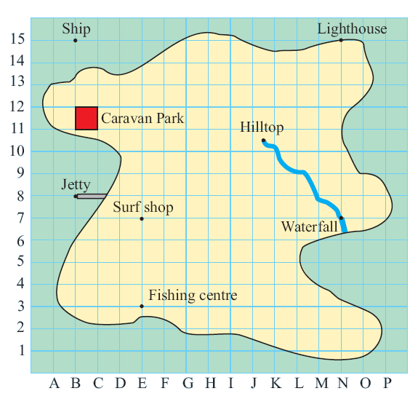

**X**

N

* 1. Give the grid reference of the Fishing Centre __________________ [1]
  2. Cathy and Simon arrive at the Jetty, give the directions using horizontal and vertical steps to help them get to the Fishing Centre

__________________________________________________________________ [2]

* 1. Cathy and Simon are instructed to get to point **X**, what compass direction is this?

__________________ [1]

* 1. When they arrive at point **X** they are given a clue. As written below. Use this information to help Cathy and Simon to answer the following questions on scale.

Give the real distance from the Surf Shop to the Fishing Centre.

**Clue 1:**

The scale of your map is:

1 square = 40 m

__________________ [2]

A walking track on the island is 500 metres long. How many squares would this be on the map?

__________________ [2]

* 1. Cathy and Simon then walk to the Lighthouse. The light house is in the shape of a rectangular prism. Work out the volume of the lighthouse.

5 m

5 m

30 m

4.5 m

Volume _________________ [2]

* 1. The large window at the front of the light house has an area of 13.5m2,

what is the height of the window?

Height _________________ [3]

* 1. Using your answer from **(f)**, determine the perimeter of the window

__________________ [2]

**Section B: 2D and 3D Geometry**

1. Name the shapes shown below: [4]

a) _______________ c) _____________ d) ______________ e) _____________

_______________ _____________ ______________ _____________

1. 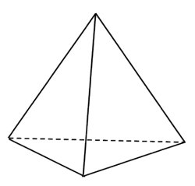 Answer the following questions about the shape shown below:

C

A

B

D

**a)** Name the shape _______________________ [1]

**b)** Name a vertex _______________________ [1]

**c)** Name a plane _______________________ [1]

**d)** Draw the net of the shape: [2]

**e)** Draw the cross-section if the shape is cut horizontally. [1]

**f)** Draw a **triangular prism** as an oblique projection [2]

1. Construct a triangle, using a compass and a ruler, with sides 3cm, 4 cm and 5 cm. Be sure to leave your construction lines in. [2]

Measure the smallest angle ___________________ [1]

Label the triangle so that the smallest angle is named <ABC (using 3 point notation) [1]

Give the definition of an obtuse angle __________________________________________ [1]

1. Use the diagram below to answer the following questions (Point O is the centre of the circle):

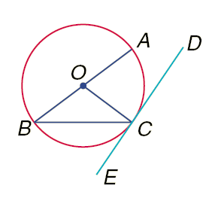**a)** Name the part of the circle shown by $\overline{AB}$

_______________________ [1]

**b)** Name a ray shown in the diagram. (Use correct notation)

_______________________ [1]

**c)** Which two lines are perpendicular?

_______________________ [1]

**d)** Name the point of intersection between $\overline{DE}$ and $\overline{OC}$

_______________________ [1]

1.  Draw the following object on the isometric paper, with the darker edges closest to you. [3]

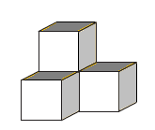

1. Draw the isometric picture using the views shown below: [3]

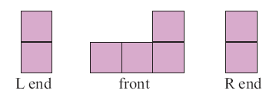

1. Draw the front, left-hand side and plan views of the following 3D shape (remember to include the required numbers for plan view) [3]

|  |  |  |  |  |  |  |  |  |  |  |  |
| --- | --- | --- | --- | --- | --- | --- | --- | --- | --- | --- | --- |
|  |  |  |  |  |  |  |  |  |  |  |  |
|  |  |  |  |  |  |  |  |  |  |  |  |
|  |  |  |  |  |  |  |  |  |  |  |  |
|  |  |  |  |  |  |  |  |  |  |  |  |
|  |  |  |  |  |  |  |  |  |  |  |  |
|  |  |  |  |  |  |  |  |  |  |  |  |
|  |  |  |  |  |  |  |  |  |  |  |  |

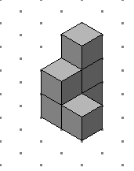

Front

**Section C: Time**

1. 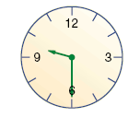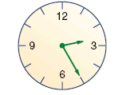Write down the time shown on the clocks below in 24 hour and 12 hour time.

AM

PM

* 1. 12 hour time: __________ [1] 12 hour time: __________ [1]
  2. 24 hour time: __________ [1] 24 hour time: __________ [1]

1. The table below is part of a bus timetable

|  |  |  |  |  |
| --- | --- | --- | --- | --- |
| City centre | 1115 | 1230 | 1310 | 1340 |
| Heatherton | 1125 | 1240 | 1320 | 1350 |
| Rykneld | 1129 | 1244 | 1324 | 1354 |

* 1. How long does the bus take to get from the city centre to Heatherton?

__________________ [1]

* 1. The 1115 bus left the City centre on time and arrived at Rykneld 2 minutes early. How many minutes did it take to reach Rykneld?

__________________ [1]

* 1. Paulo walked to the bus stop at Heatherton and arrived at 1256. The next bus arrived on time. How many minutes did Paulo wait for the bus?

__________________ [1]

1. 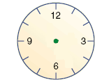Draw the 24 hour times below onto the blank clock faces, state whether the time is AM or PM in the space provided. [2]
   1.  **b)**

____________ ____________

**c)** What is the difference between the two times in minutes?

__________________ [1]

**d)** Convert your answer from (c) to seconds

__________________ [1]

1. Study the time zone map below

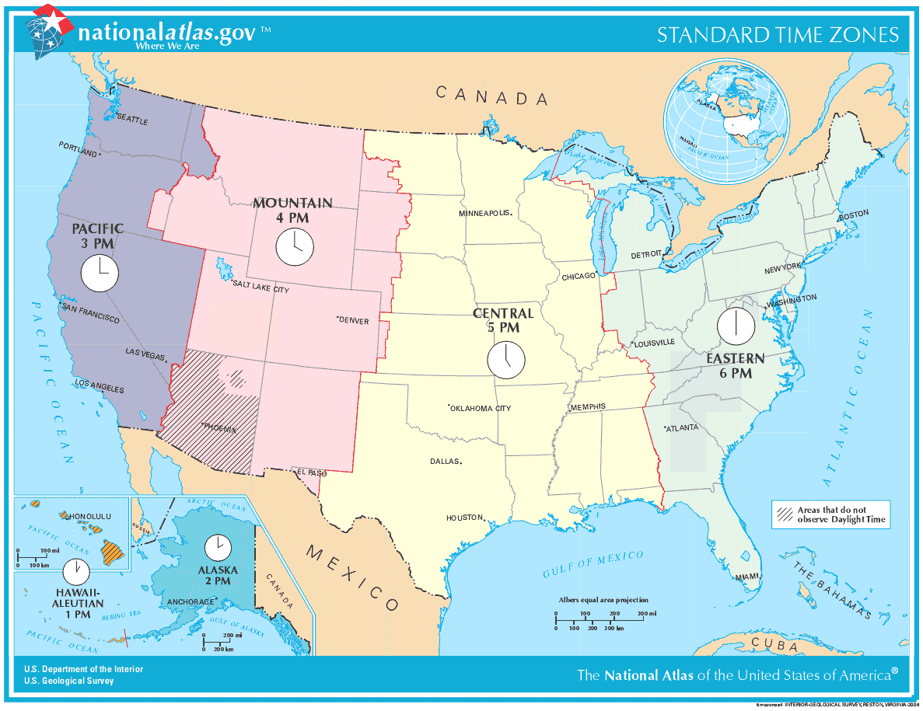

* 1. If it is 4:00 AM in the Central Time Zone, what time is it in the Eastern Time Zone?

__________________ [1]

* 1. If it is 10:00 AM in the Eastern Time Zone, what time is it in the Pacific Time Zone?

__________________ [1]

* 1. Alicia flew out from Alaska at 3:00 PM and arrived in the Pacific Time Zone 4 hours later, at what time did she arrive (Pacific Time)?

__________________ [2]

**Section D: Statistics**

1. Draw a stem and leaf graph in the space provided for the following data. Do not forget **titles** and **labels**. You graph does not need to be in order. [4]

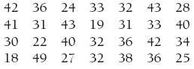

|  |  |  |  |  |  |  |  |  |  |  |  |  |  |  |  |
| --- | --- | --- | --- | --- | --- | --- | --- | --- | --- | --- | --- | --- | --- | --- | --- |
|  |  |  |  |  |  |  |  |  |  |  |  |  |  |  |  |
|  |  |  |  |  |  |  |  |  |  |  |  |  |  |  |  |
|  |  |  |  |  |  |  |  |  |  |  |  |  |  |  |  |
|  |  |  |  |  |  |  |  |  |  |  |  |  |  |  |  |
|  |  |  |  |  |  |  |  |  |  |  |  |  |  |  |  |
|  |  |  |  |  |  |  |  |  |  |  |  |  |  |  |  |
|  |  |  |  |  |  |  |  |  |  |  |  |  |  |  |  |

1. Determine the mean, median and mode for the following data:

$18, 23, 7, 26, 17, 7,14$

Mean:________ Mode: ________ Median: ________ [3]

$45, 57, 47, 49, 57, 52, 46, 50, 35, 42$

Mean:________ Mode: ________ Median: ________ [3]

1. Vanessa surveyed her school and found that 13 of the 40 people she questioned had chosen chocolate as their favourite ice cream flavour. Extend this to the whole school of 800 – how many would you expect to choose chocolate ice cream as their favourite?

________________ [2]

1. Complete the frequency table for the shapes in the rectangle below. [3]

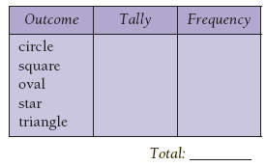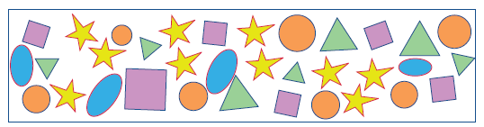

1. Study at the graph below carefully and then answer the following questions.

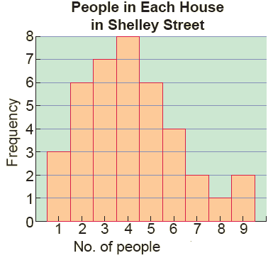

* 1. What is the most common number of people per house?

______________ [1]

* 1. How many houses have 5 people in them?

_______________ [1]

* 1. Work out the total number of houses in Shelley Street.

_______________ [1]

* 1. Calculate how many people live in Shelley Street altogether.

________________ [2]

**Section E: Patterns (Algebra)**

1. Fill in the missing number from each pattern [4]
$4, 9, \left[ \right], 19, 24$

$4, 9, 19, \left[ \right], 54, 79$

$6, \left[ \right], 24, 48, 96$

$100, \left[ \right], 25, 12.5$

2. Fill in the gaps for the following equations: [4]

(a) $$9+\left[ \right]=12$$

(b)

$\left[ \right]÷7=9$

(c)

$\left[ \right]×4=52$

(d)

$\left[ \right]-27=5$

1. Use the matchstick pattern below to fill in the table [2]

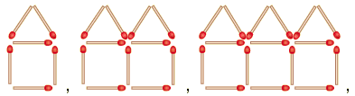

|  |  |  |  |  |  |  |
| --- | --- | --- | --- | --- | --- | --- |
| Number of Houses (n) | 1 | 2 | 3 | 4 |  | 15 |
| Number of Matchsticks (M) | 6 |  |  |  |  |  |

* 1. Give a formula to determine the number of matchsticks:

M = _________________ [2]

* 1. Give the number of houses which would have been made with 31 matchsticks

_____________ [1]

1. A farmer wishes to re-fence along one straight side of a large paddock. The farmer wants to use a post and rail fence, but is concerned about the cost. Posts cost $24 each and two-metre rails cost $10 each. The fence will need to be 100 metres long. The farmer draws up a table (shown below) to help her determine the cost:

|  |  |  |  |
| --- | --- | --- | --- |
| Diagram |  |  |  |
| Number of Posts | 1 | 2 | 3 |
| Number of Rails | 0 | 3 | 6 |
| Distance | 0 | 2 | 4 |

* 1. Find the number of rails and posts required for a 100 metre, three-rail fence. And hence find the total cost.

Number of Posts: _______________ [1] Number of Rails: _______________ [1]

Total Cost: ____________________ [3]

* 1. Another farmer builds a fence using 12 posts and the same 2 metre long rails, how far does his fence stretch?

____________________ [2]

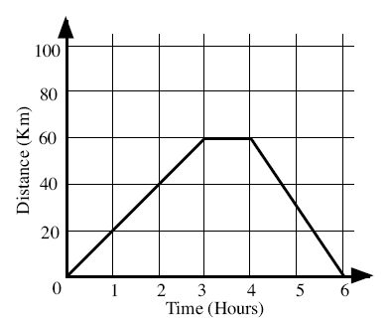

1. The graph shown, describes Adele’s day out on her bicycle. Study the graph carefully and then answer the questions below:
   1. How long did Adele spend stationary?

_____________________ [1]

* 1. How far away from home was she after 1 hour?

_____________________ [1]

* 1. What is the total distance she travelled?

_____________________ [1]

* 1. Adele’s brother Johnny also went for a bike ride, it took him 3 hours to cycle 40 km. He then stopped and waited for his sister, they then rode home together at the same speed. Draw in Johnny’s trip on the graph. [2]

**Section F: Probability**

1. What does it mean for something to be impossible?

__________________________________________________________________________

__________________________________________________________________________[1]

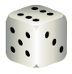

1. For each event choose one of the categories: impossible, unlikely,

even chance, likely or certain

* 1. Event 1: A 6 will be thrown ___________________ [1]
  2. Event 2: A zero will be thrown ___________________ [1]
  3. Event 3: A prime number will be thrown ___________________ [1]

1. In a cardboard box I have 37 red pens, 120 black pens and 43 blue pens. If one pen is chosen at random, find the probability that the pen is:
   1. Red

____________________ [1]

* 1. Not black

____________________ [1]

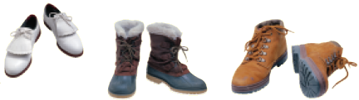

1. I have three pairs of shoes in a box. I chose one shoe and I am to choose a second at random. What is the probability that:
   1. The second shoe will match the first?

____________________ [1]

* 1. The second shoe will not match the first?

____________________ [1]

1. 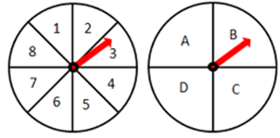Work out the number of possible outcomes of spinning the spinners shown: [2]

First

Second

**Section G: Transformation Geometry**

1. Draw all the lines of symmetry in the following pictures (if they have any) and state the order of rotational symmetry

**O**

**(a) (b)**

[2]

Order of rotational symmetry: Figure (a) ________________ [1]

Figure (b) ________________ [1]

1. Draw the mirror image of the objects below. [4]

________________________________________________________________________________

1. Describe a **single** transformation **in full** that would transform A to A’ and B to B’. If giving a reflection please draw in the mirror line.



**(a)** **(b)**

*Not drawn to scale*

**B**

**B’**

**A’**

**A**

9 cm

3cm

*Answer (a)* _____________________ *Answer (b)* ____________________

____________________________ [2] ____________________________ [2]

1. Draw an enlargement of the figure shown using, centre of enlargement ‘O’ and a scale factor of 3. [3]

O

**Section H: Problem Solving**

1. The king’s palace is square. He would like it to be surrounded by 4 trees on each side. How many trees would you buy to surround his palace if he asked you to be in charge of this task?

___________________ [1]

1. Carla needs to cut a piece of wood that is 32 cm long into 8 pieces. It takes her 1 minute to cut 1 piece. How long does it take to complete this job?

___________________ [1]

1. I have a number in my mind. It is an odd number. It is between 40 and 60. The sum of its tens numeral and its ones numeral is 11. What is my number?

___________________ [2]

1. I am 8 years old now and my father is 41 years old. After how many years will my father’s age be twice my age?

___________________ [2]

1. Mrs Mills puts some chickens and rabbits in one cage. There are 20 heads and 64 legs in the cage. How many chickens and how many rabbits are there?

Rabbits _____________ Chickens _____________ [2]

1. There are 3 teachers: Mr A, Mr B and Mr C. Between them they teach Maths, English, History, Chemistry, Physics and Biology, and each of them teaches 2 subjects. This is what we know about them:

1. The teacher who teaches chemistry lives with the teacher who teaches maths

2. Mr A is the youngest teacher of the three

3. The Maths teacher and Mr C are very good rugby players

4. The Physics teacher is older than the teacher who teaches biology but younger than Mr B.

5. The oldest teacher lives further away from the school.

Which two subjects do they teach?

Mr A: 1._____________ 2. _____________

Mr B: 1._____________ 2. _____________

Mr C: 1._____________ 2. _____________ [4]

1. Dora is helping her grandma collect eggs. She gets three cartons of different sizes to hold the eggs. She puts half of the total plus a half egg into the biggest carton. Then she puts half of the amount of eggs that are left over plus a half egg into the middle-sized carton. Lastly she puts half of the remaining eggs plus a half egg into the smallest carton. How many eggs has she collected altogether?

______________________ [3]